**N2CMS.com proposal for setup***MR 201204*

This document describes a proposal for a setup of N2CMS.com.  
The proposal is in a draft state.

There is a desire to create a new website for the open source content management system N2 and the company behind N2. So far the company has been a single person but there is a desire to make it in to a professional organization.

Based on some basic mockup’s we’ll try to explain the general setup we have in mind for N2cms.com.  
Please note that design and page setup is still in draft, the (sub)menu for instance can be better.  
For now the mockups are created to give a general overview and mainly an idea of the setup.  
  
We have not separated the open source and commercial intentions in completely separated sections, we intentionally merged the both to make sure everybody knows there is a good company behind the system that also provides professional services and additional products. Next to that, the attention value to promote these services and products is the best where the first attention goes to, open source.  
We think it would be good to have the commercial company to build some add-on’s and sell them.   
With high value add-on’s this provide a part of the income and a good visible understanding of the desires of the users/developers.

Based in the information provided we think the site should be separated by a main menu in these sections, covering all wishes in the documents:

* N2 [*Better title?*]  
  a section which should describe “What is N2?” for every interested party (of which there are mainly developers and users and both of them as potential, new and established).
* Products  
  This section should list and explain all products, give info on them, use screenshots to make clear what the products do and can do etc.   
  Intent is that not only the N2CMS system is a product, but the commercial company will also provide products.  
  Of course it is important to have the open source system as the base and make sure everybody knows it is free, but the commercial services and products are best listed here!  
  *This section might be filled (and used) later on (after live of the new site), when more than one product is available. Until then it might be “Download” to list all download options for the N2 CMS.*
* References  
  Show the world what websites, webshops and webapplications have been created with N2.   
  Optional: Let partners add their own listings and let all other developers and users post & upload (screenshots!) their listings for approval. Also show testimonials.
* Partners  
  A partner section intended to list the ‘approved’ partners of N2CMS. On the one hand a section where they can advertise their companies and on the other hand [*optional*] the location to access a partners portal [*Future!*] with advanced “features”.
* Community  
  As in everything developer related. We foresee a wiki (=documentation center), forum and an online (payed?) helpdesk/ticketing system [Possibly in the f*uture*].   
  Although external tools where offered to be used, we would love to let the world see that all tools can be built with N2 and integrated to each other and the entire site. I think it will be a good showcase *not* to use external tools here….   
  Or we can use external systems like Codeplex and integrate the result in the n2cms.com website. Something to try.
* Team  
  Who is behind N2?

A mockup / wireframe for a potential homepage setup:  
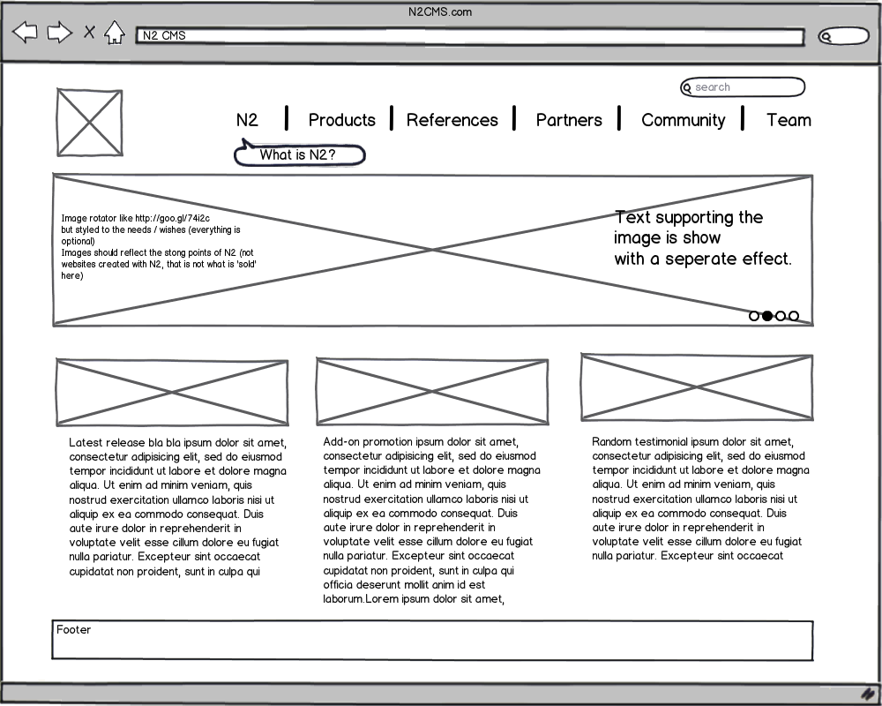

Our main goal, also where the discussion internally was, is to make sure all targeted visitors can find the info they need. The targets being developers and users in one of the tree states, potential, new or existing. Next to that the 2nd main goal was to let the world know and see that a professional company is behind the product, creating it, backing it up and extending it with open source and commercial services and products.

In the end “you should have been in the discussion” but that was a bit difficult.  
We discussed more details that described here to have a feel where to go with the site.   
But now we want to know if the direction is a good one before continuing to a next step, the discussion with you for the details, extending the mockups with just that, create a design based on the mockups and the desires you have and built the website!